**SOFTENG 350**

**Tutorial 1: Design Walkthrough**

**Worth 1% of your final grade**

**Tutorial exercises should be undertaken in pairs**

**Fill out your responses in this worksheet, in your own words**

**You should plan to spend 40 minutes on this tutorial**

**Upload your completed worksheet to Canvas**

**Due in your tutorial, or by 6pm on Friday 13 March**

**Aims**

The aim of this tutorial is to give you experience in undertaking a design walkthrough for a software system. You will practice this skill in Assignment 1.

**Background**

Your task is to to do a design walkthrough in order to evaluate the UX of the Student Portal website (<https://myaucklanduni.ac.nz/>)

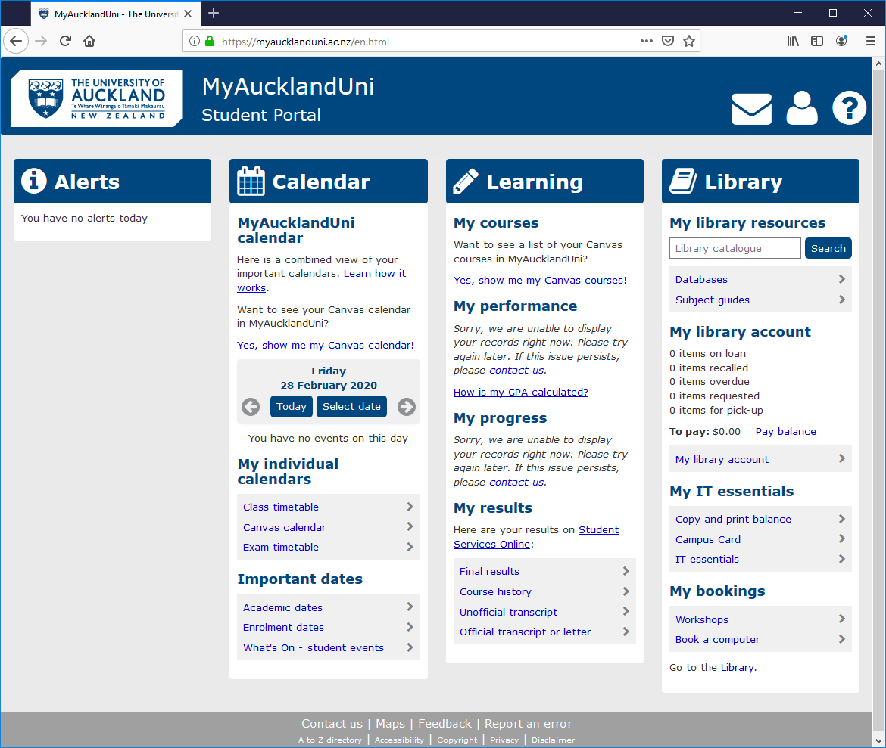

We will follow the design walkthrough approach described in lectures and from the reading of Chapter 25.2.

**Activity 1**

As a pair discuss the user experience, and in particular the usefulness, of the Student Portal homepage. Record each problem clearly and succinctly in the box below as bullet points:

|  |
| --- |
| * Style of student portal is different to main university website * The usage of the alerts column is not clear. * Each link takes you to a different website, so a little jarring. * Library does not automatically sign you in * Help button goes to general feedback form for UoA instead of a tutorial/explanation * Need to sign in for book a computer again * Only useful a few times, as you can just learn the link that you need * Ease of use: Good grouping of sections, nicely labelled sections, links are obvious except for the top left University logo * Fit for use: The system is more useful as a hub for links. The calendar is small and not expandable so has limited use. The links to canvas are not very useful as these are easily accessible on canvas. * Ease of learning: Quite a lot of information at first, but after looking at the headings, is intuitive. Most links are blue, however some are underlined and some have arrows. * Efficiency of Use: Geometric layout is good for recognition, so an experienced user would be able to accomplish tasks quickly * Memorability: Static placing for all elements, so user should not be confused when looking at the system again. * Subjective Satisfaction: Looks outdated, gaps on bottom and the sides of the screen. |

**Activity 2.1 and 2.2**

In your pair choose one person to be the guide for the *My library account* section and the other person to be the guide for the *Copy and print balance* section. As your partner guides you through their section you should record any user experience problems you can see in the box below as bullet points.

Edit the table title so it shows which section you are recording user experience problems for:

|  |
| --- |
| *My library account* |
| * Have to sign in again when coming from student portal * Clicking sign in just refreshes the page, only when clicking again does it work * “Full text available” shows a link to a database which does not allow you to read it * Only one option for loan period dropdown – why is this an input field then? * Only one option for material type * “Not needed after” field seems redundant as we have already specified a 28 day loan * There is a cross button which overlaps with the “Not needed after” field so you can not see the date selected clearly * Comes up with audio version of book first * Multiple versions alert is ambiguous and unintuitive * Description for book has no meaning for the user * No obvious button to lend book * No confirmation on send to email button * X which is not clickable and has no meaning shows up beside email and note fields. * Citation is under the send to section |